**Questions about the data:**

* Calculating the average diesel consumption in L/kWh, the values significantly vary and do not correlate with the operation time 🡺 Any explanation for this?
* There are two columns named (1) “Selling Price (LBP/KWh)” and (2) “Selling Price ($/KWh)”: Why are there no entries for (1) after March 2023 while there are entries for (2) for the entire observation time?
* Closely related to the previous point: Are there significant differences in the results to be expected depending on if we estimate electricity demand elasticities in (LBP/kWh) and ($/kWh) because of the enormous high inflation? 🡺 From my viewpoint, it might be helpful to stick to $/kWh in the results (especially for the publication)
* What exactly is meant by “Governmental pricing ($/kWh)? Is it some sort of recommendation/benchmark for the “Selling price ($/kWh)” or is it the selling price of electricity of the public grid (which is only very limited available)?

**Additional data that might be needed:**

* Do we know anything about the onsite solar photovoltaic generation within the area? Here I mean both, solar-based generation of the utility company’s capacities and decentralized solar-based generation from households?
* From my viewpoint, the previous point is critical when it comes to the electricity demand elasticity because, for example, when we assume that somewhere in time decentralized solar-based generation has been installed, this affects the users consumption already? So in other words, the total installed capacities in the area of all stakeholders are needed?

Notes from meeting with Haytham (27.08)

* Aggregated data for the entire district, which consists of three microgrids in total
* Substantial differences in the efficiency of the diesel generators
* District name: **Deir Qanoun En Nahr**
* Results should be provided in $/kWh
* Small week storage available for the district (approximately 45,000l diesel)
* “Governmental pricing” 🡺 “Obligatory rate” but today it is more a benchmark for comparison as the power of the government has vanished (it the past, the private company came in trouble if prices where remarkable different, but today not anymore)
* 15,000 inhabitants
* <https://www.weatherworld.com/yearly-climate/lb/tyre.html>
* 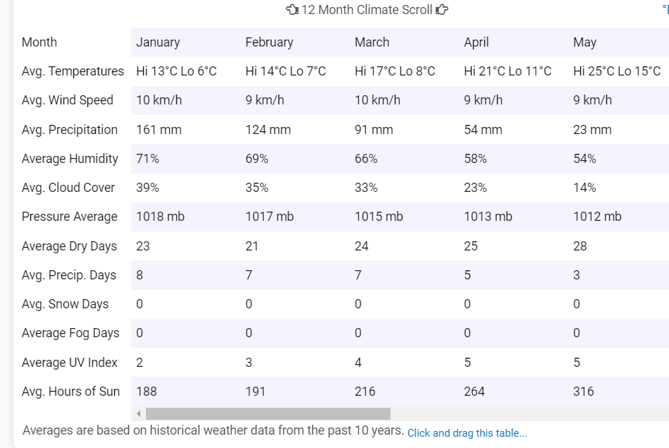
* 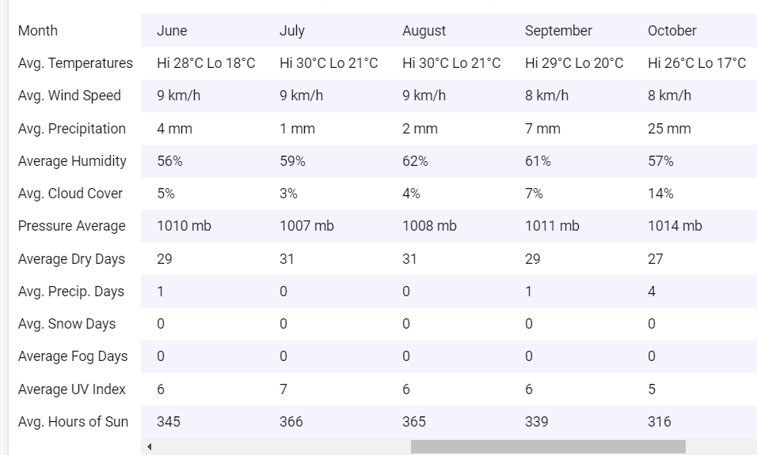
* 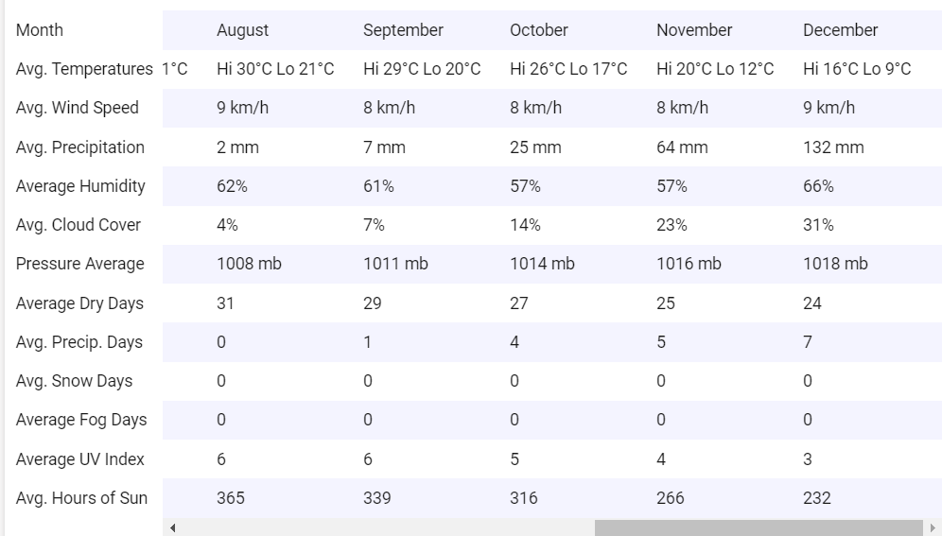
* 4-6 hours at max is the availability of the public grid
* 30% Industrial demand, and 70% Residential demand
* 740kWp solar farms and 1,500kW rooftop solar PV systems (550 units) 🡺 20% before the 2022, 80% after 2022
* 1300 units (consumer points): 160 industrial consumers (factory, supermarkets), 16/84 for residential consumers